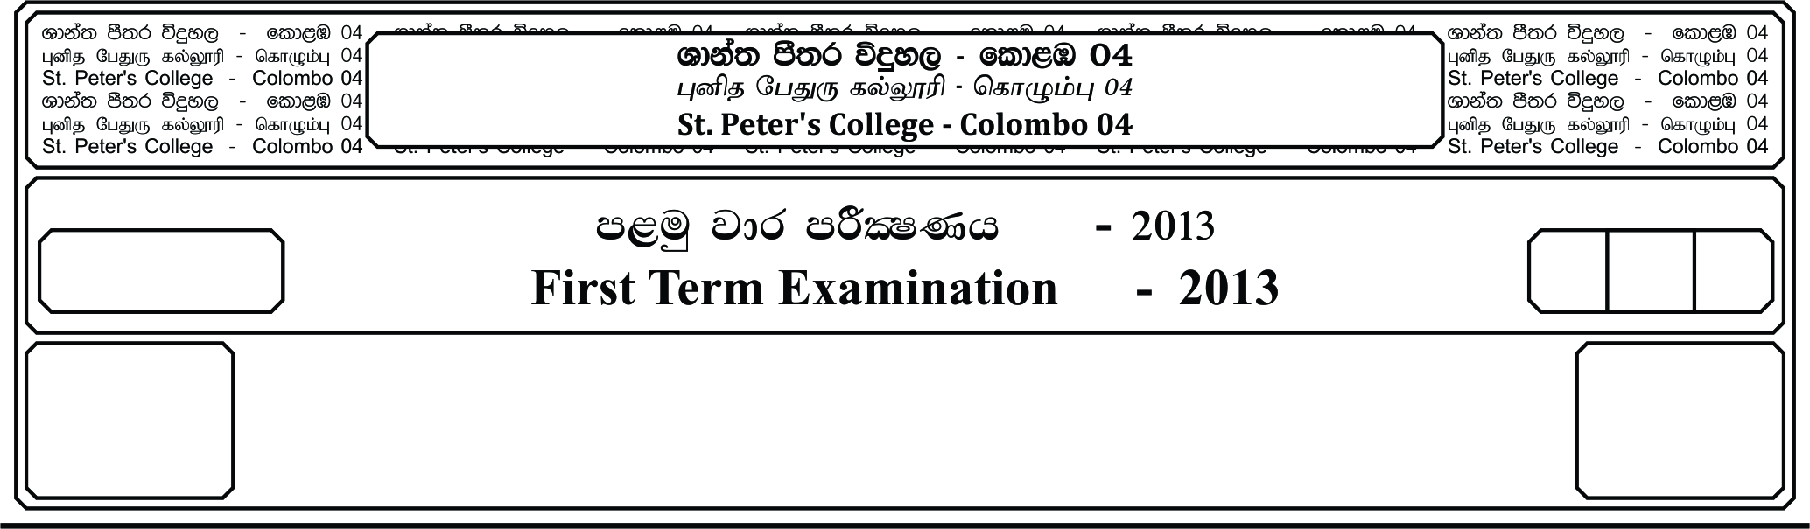

l%sia;shdks O¾uh - »

**Christianity - I**

**m<uq jdr mßlaIKh - 2019**

**First Term Examination - 2019**

E

12 fY%aKsh

GRADE 12

I

meh 02

02 Hours

**Answer all questions.**

1. Without having any dealing with Pharaoh Mosses and Aaron allow these pleauges to take place.

i. 1, 4, 7 ii. 2, 5, 8 iii. 3, 6, 9

iv. 1, 5, 6 v. 3, 4, 7

2. The night of the 14th means in the month of Nisan,

i. The 1st poya of the month of February. ii. Poson poya of the month of June.

iii. The 1st poya of the month of January. iv. The last month of the year.

v. The 5th month of the year.

3. The Hebrew word for unleaven bread,

i. Matsah ii. Esen iii. Rchoboth

iv. Isaiah v.

4. The prophet __________ was known as the impartial prophet.

i. Amos ii. Ezekiel iii. Isaiah

iv. Hosia v. Mica

5. According to the Hebrew language the meaning of prophet is __________

i. The one who speak on behalf of others ii. One who pleads before others.

iii. Messenger of angel iv. The angel

v. Prophet

6. “Hokma” means,

i. The ability to face the blameless and rational life.

ii. The ability to lead another on the correct path.

iii. The ability to make confusion in the lives of others.

iv. Face life courageously

v. To select to lead a bitter life.

7. Theoneutos is known as,

i. God given birth ii. Inspiration iii. Divine authorship

iv. Fivine inspiration v. Divine consolation

8. __________ translated the Holy Bible into Latin.

i. St. Athanasius ii. St. Jerome iii. King Tolomi

iv. Pope Damascus v. St. Paul

9. “The copy of common man” name as,

i. Vulgate ii. Massorotic iii. Greek

iv. Copy of Septuagint v. Holy Bible

10. According to the 1st creation story, God created __________ on the second day.

i. Sun, Moon and Stars ii. Land, Sky

iii. Day and Night iv. Birds and Fish

v. Sky and Water

11. The fall of man was written in __________ tradition,

i. J ii. E iii. D

iv. P v. P and E

12. The meaning of “Negeb”

i. Dry ii. Life iii. Water

iv. Air v. Death

13. The meaning of Tower to Babel is,

i. Confusion of the languages ii. Reach out to God

iii. God’s word iv. Messenger of God

v. One nation

14. During the time of Christ, Palestine was under the regime of,

i. Romans ii. Judea iii. Greek

iv. Galatia v. Samaria

15. According to the 2nd creation story man was punished in two ways.

i. As long as man lives, he has to find his food and has to face death.

ii. Man controls the woman and turn against God.

iii. As long as man lives he worship other Gods.

iv. Woman creates problems.

v. Man and woman turn against God.

16. According to the Tower of Babel Gen – 11 : 1 – 9

Man’s __________ was his fall.

i. Conceit ii. Jealousy iii. Sin

iv. Pride v. Anger

17. The chapters belong to the pre-history of the book of Genesis are,

i. 12 – 50 ii. 1 – 11 iii. 1 – 5

iv. 5 – 10 v. 1 – 50

18. The background was made for the 2nd creation story through the story of Exodus. Therefore there is a

thick bond between these two stories. If the above saying is true mark it as right of it’s wrong, mark

it as wrong.

i. True ii. Some what iii. May be

iv. Not true v. Cannot be

19. In the garden of Eden, man was entrusted with two responsibilities.

i. To cultivate it and to protect it. ii. To recreate it

iii. To take over it and protect it. iv. To share it will other and took after it.

v. To be like God in cultivating

20. In the story of flood and according to the ‘J’ tradition the flood lasted for __________

i. 354 ii. 40 iii. 10 iv. 365 v. 100